Description | I’m trying to recreate this image I found, but I can’t figure out the phrase to make it. Can you help me out?
Files | image.png  challenge.exe
Hint(s) | None
Walkthrough | The user is given an executable and this image:  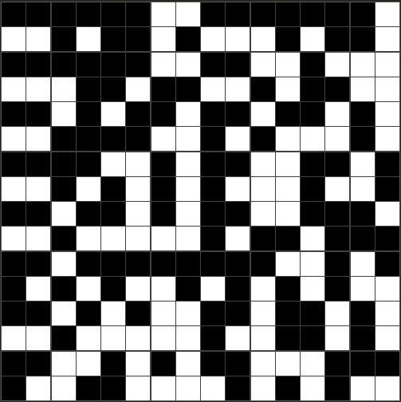  When running the executable, the user is prompted to enter a 32 character string. When they do so, an “image” made up of #’s and _’s is printed.  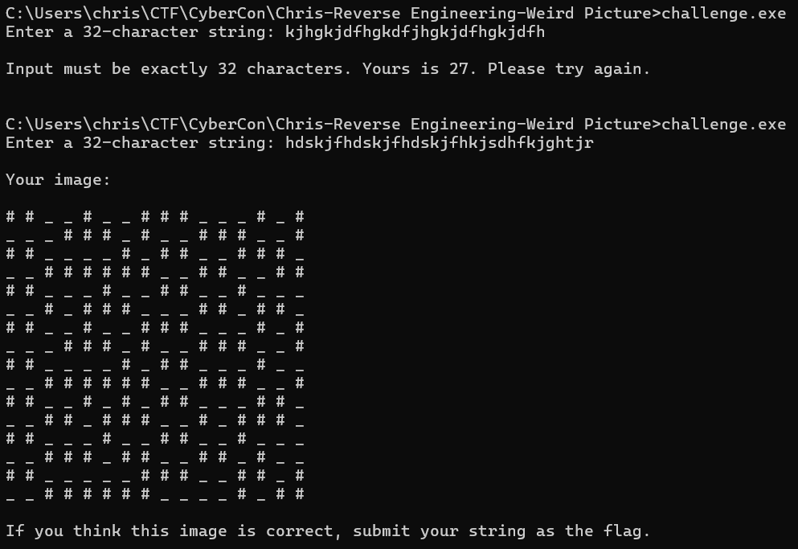  The first course of action would be to experiment with different strings and try to see how they affect the image.  I loaded the exe into Ghidra, and I was able to find the main method when searching for strings.  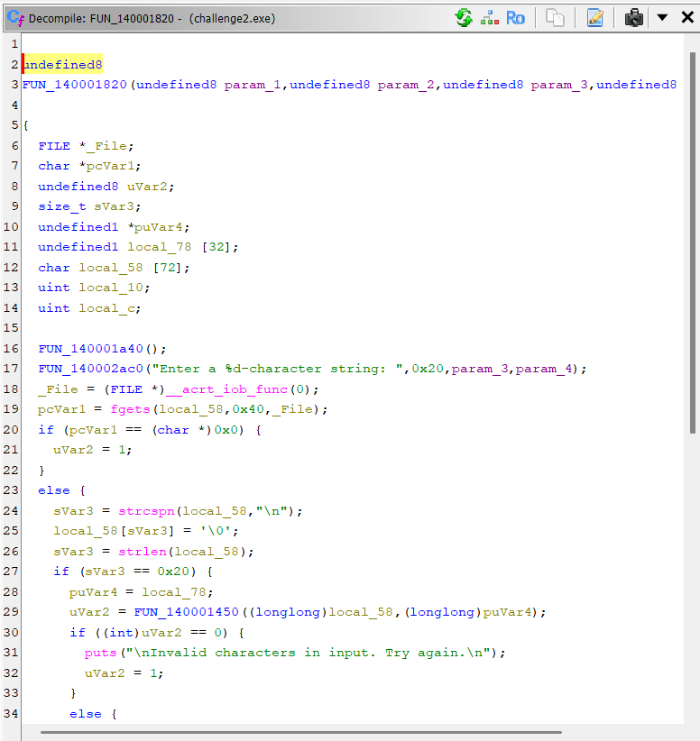  We find this function being called on the input:  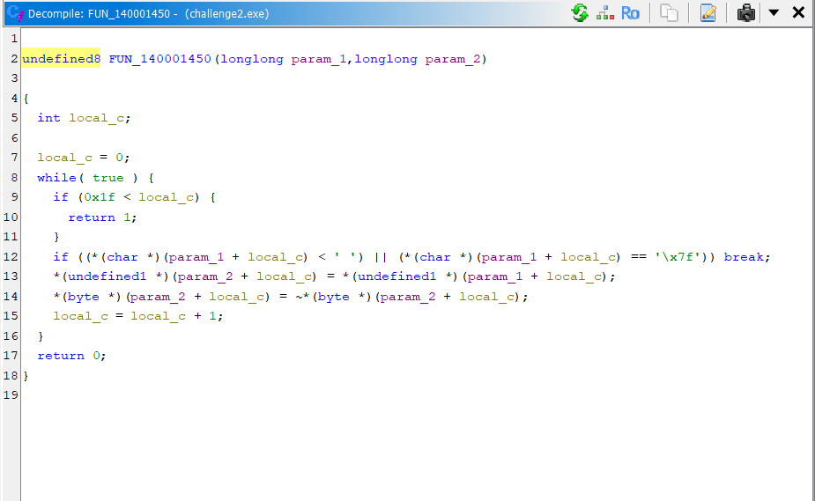  Here’s what I was able to pick up on:  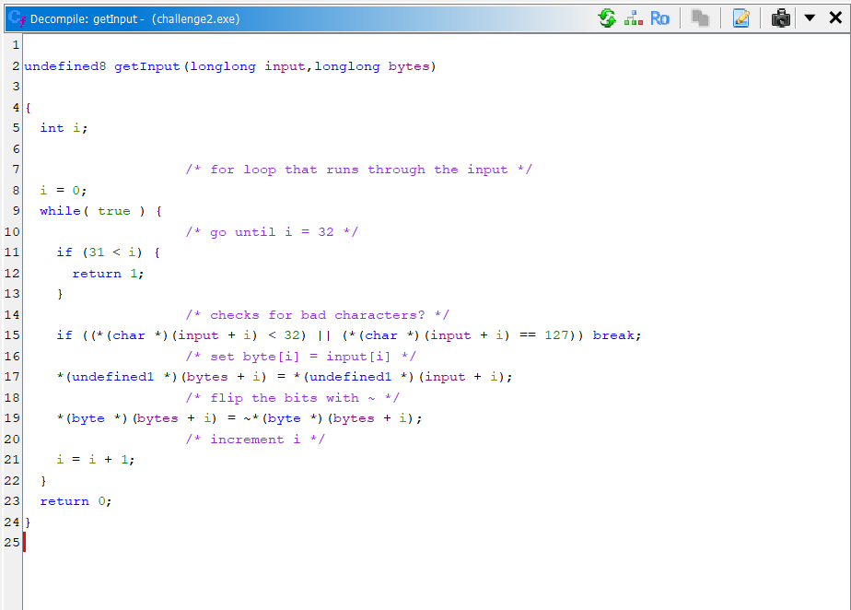  It looks like a function that is supposed to get the input, store the ascii values of the characters as bytes, and flip all the bits.  Continuing through the main method, we run into a new function (FUN_140001637):  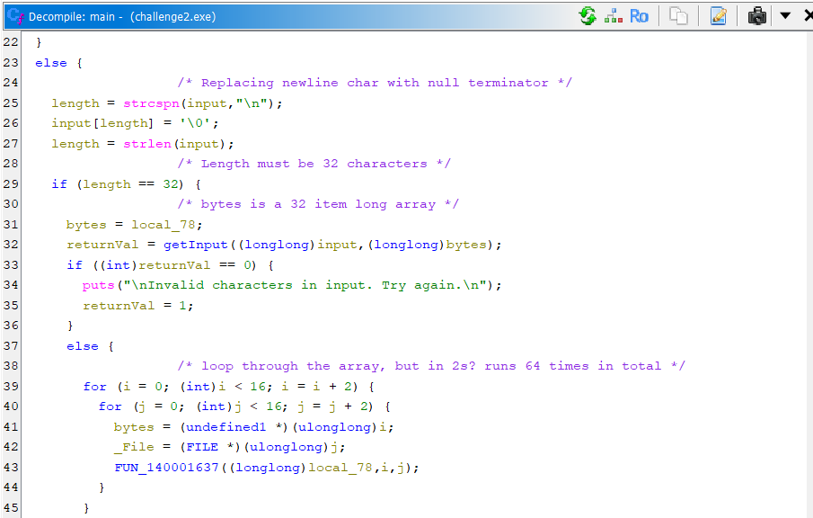  This one is relatively short, but has a lot of function calls:  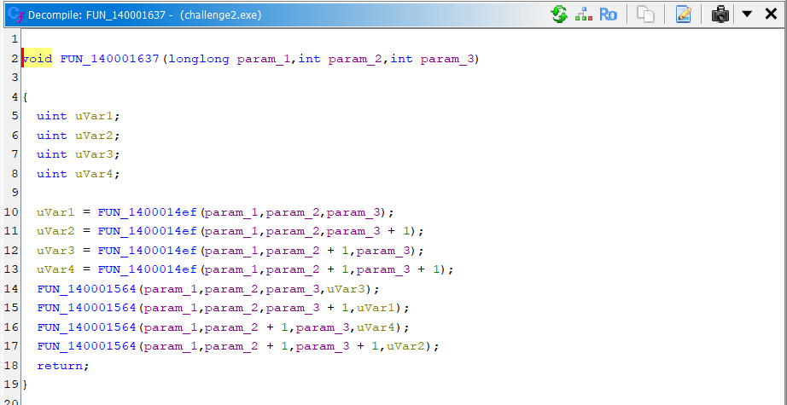  First, I will look at FUN_1400014ef.  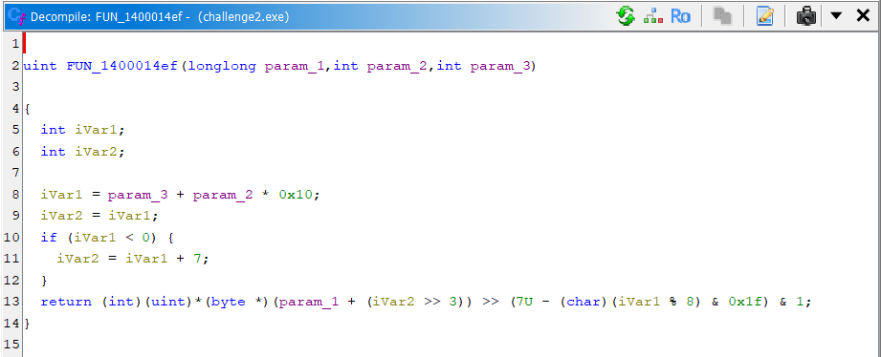  After some head scratching, I’ve deduced this is a method to get a bit at a specific index. It looks like the array of bytes is rather treated as a 2d array for the image creation.  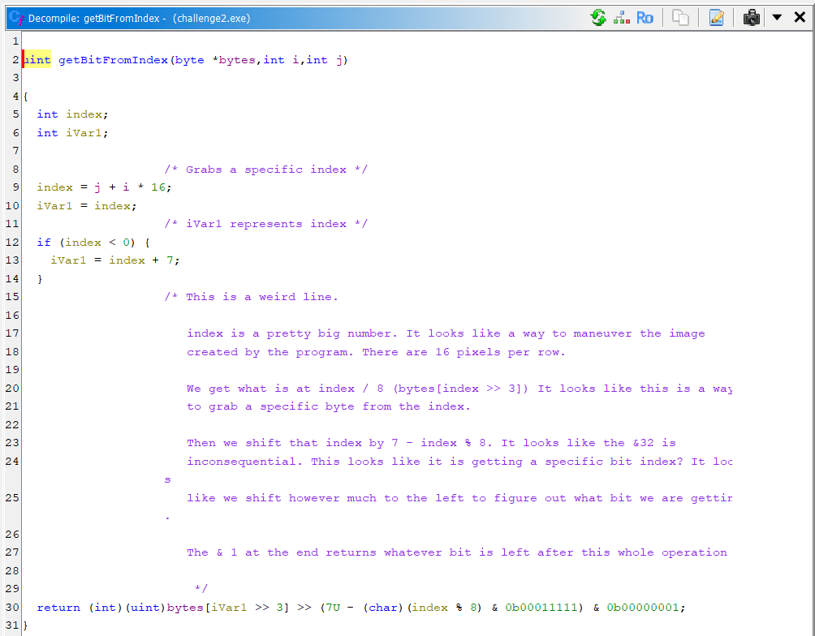  It looks like it gets the bits all in a square. Now we need to figure out the next function.  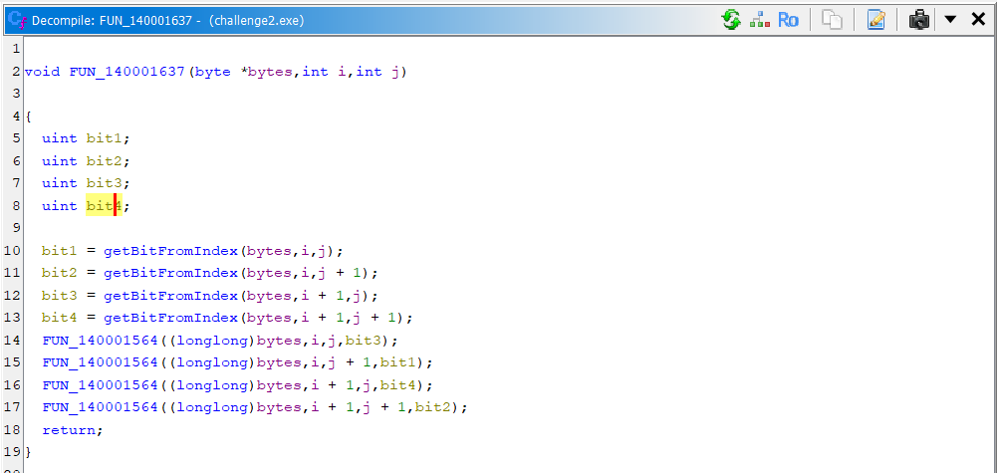  Here is the next function.  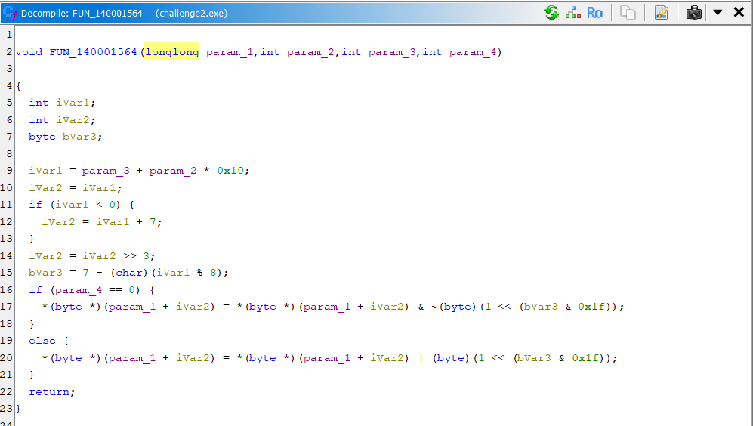  It looks like this function sets the bit at the index to the bit passed in the parameter.  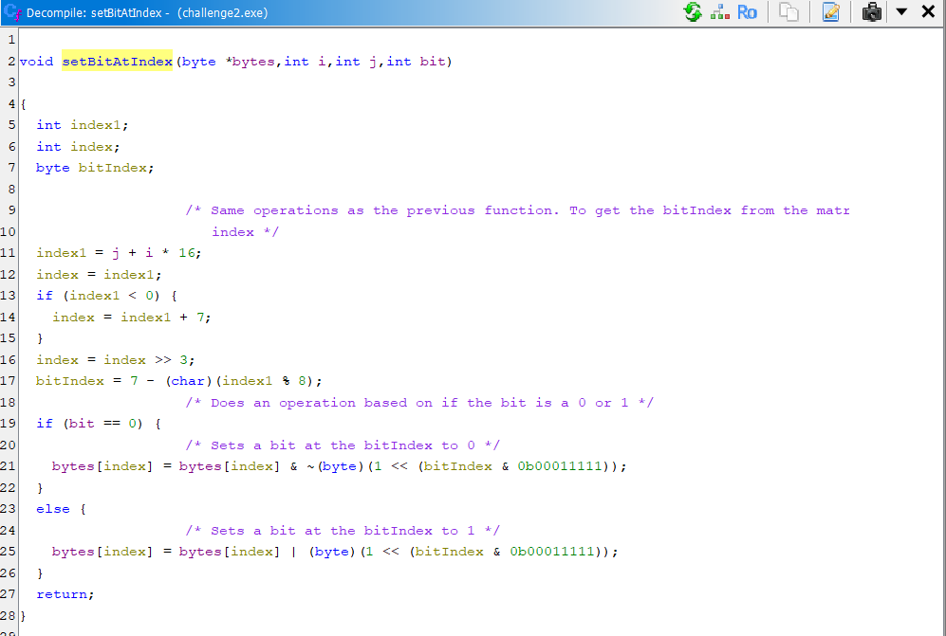  Therefore, the function rotates bits clockwise in squares.  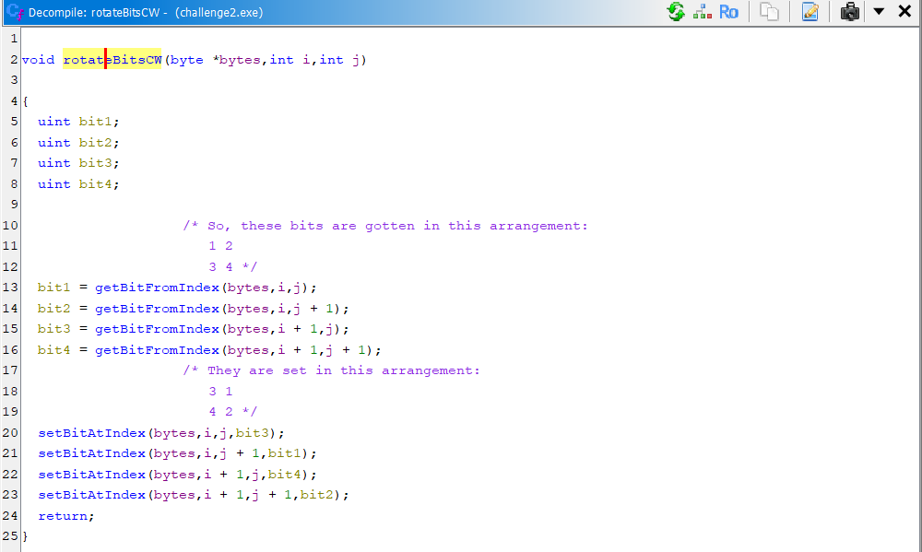  Now, we just have 1 more function (FUN_140001733)  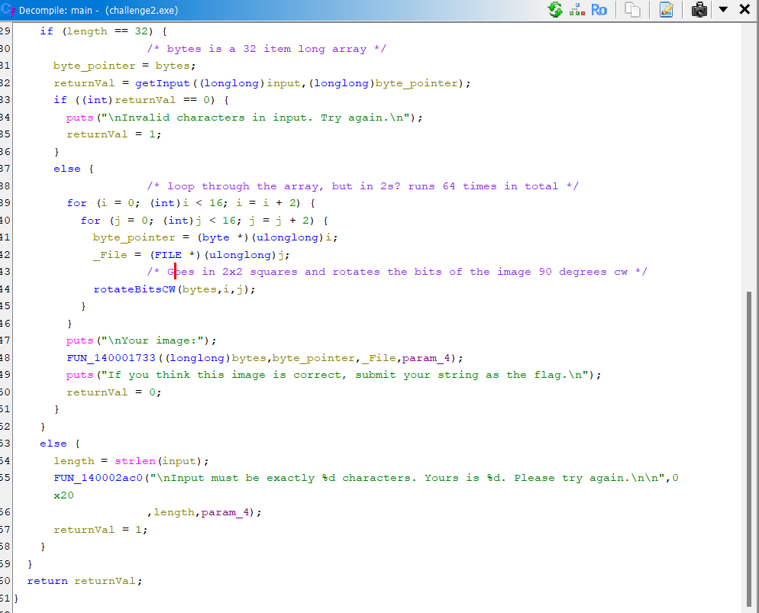  Here is the function:  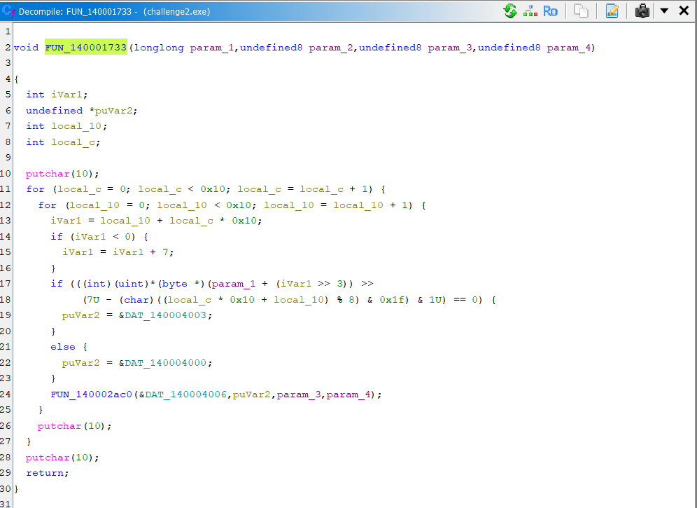  It just prints the characters in the image.  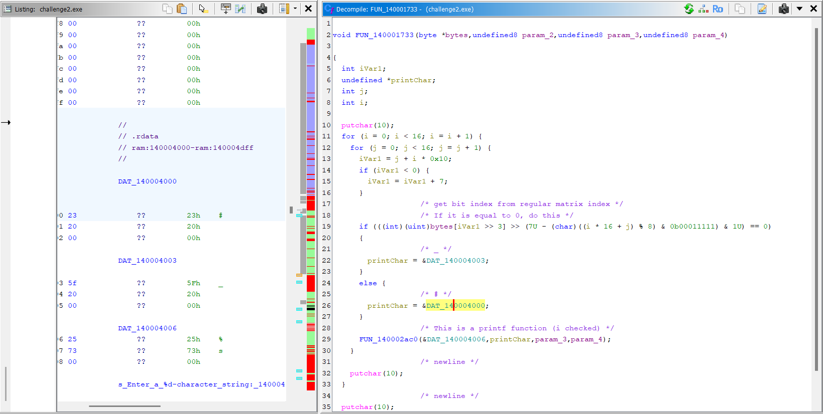  So, we now know everything this program does. First, it takes a 32 character string as input. Then, it casts all the characters to bytes and flips the bits. Then, it rotates those bits in 2x2 blocks counterclockwise and prints the bits as “#” for 1’s and “_” for 0’s. Now, we can try to reverse the algorithm to get our correct input string.  After writing a quick solver in java, I got the original code to create the image.  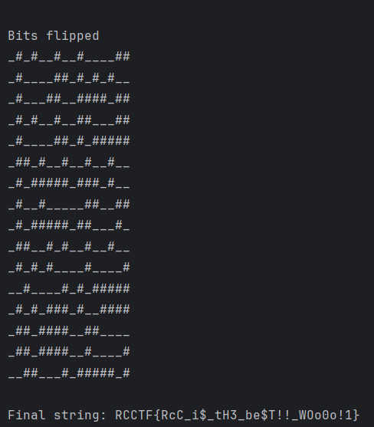
Flag | RCCTF{RcC_i$_tH3_be$T!!_WOo0o!1} (Case Sensitive)

